# ECC Example with the Calculator.

Use <https://cdn.rawgit.com/andreacorbellini/ecc/920b29a/interactive/modk-mul.html>. Be sure you are on the Fp multiplication page. For this example, we will use the page default settings. Our curve will be *y*2 = *x*3 + 2*x* + 3 (a = 2 and b = 3), and our modulus/field will be 97. Our base point will be P: (3, 6). Note that it is not a secure example, as the subgroup only has 5 points.

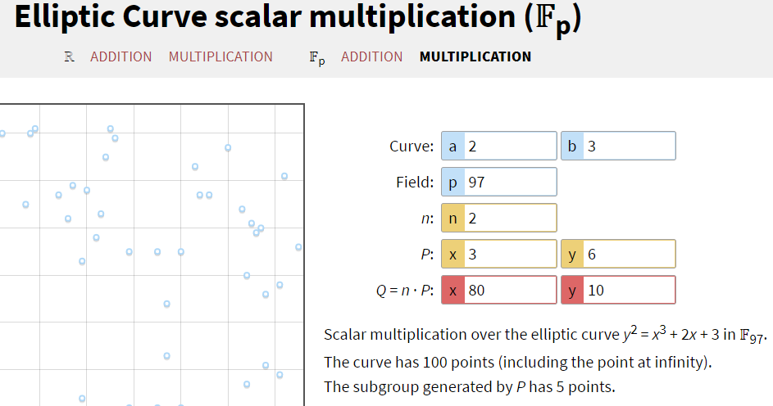

So far, we have selected the public information.

Curve *y*2 = *x*3 + 2*x* + 3 Modulus 97

P 3, 6

## Alice’s Public Key

Let’s say that Alice selects 9 as her private key, a. She puts 9 into the n: box in the calculator to compute 9*P.  
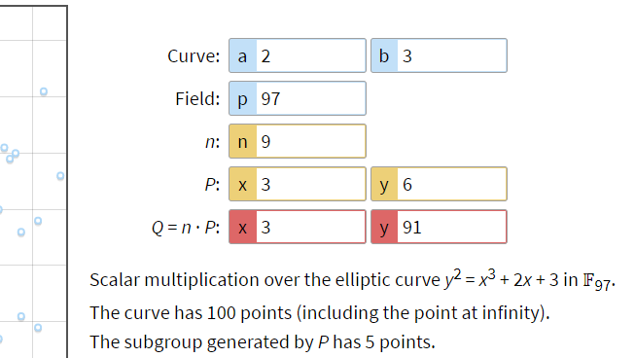

The result is that her public key is (3, 91) which she gives to Bob.

Alice  
Select a _____9_____  
Compute A ___3, 91____ A = a P  
Give A to Bob

## Bob’s Public Key

Let’s say that Bob selects 7 as his private key, b. He puts 7 into the n: box in the calculator to compute 7*P  
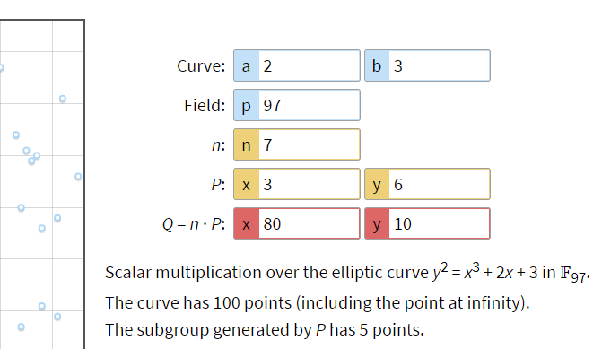

The result is that his public key is (80, 10), which he gives to Alice.

Bob  
Select b ____7______  
Compute B __80, 10____ B = b P  
Give B to Alice

## Alice computes the shared key

Alice puts her private key, 9, in the n: box. She puts Bob’s public key (80, 10) in the box for P:  
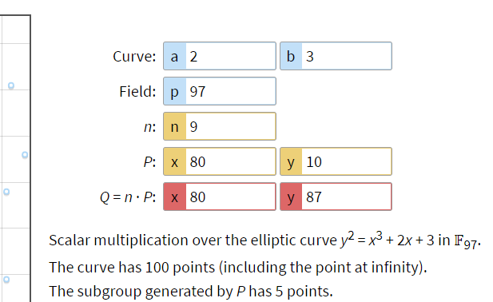  
The result is (80, 87), so she uses the X coordinate 80 as the shared key.

## Bob computes the shared key

Bob puts his private key, 7, in the n: box. He puts Alice’s public key (3, 91) in the box for P:  
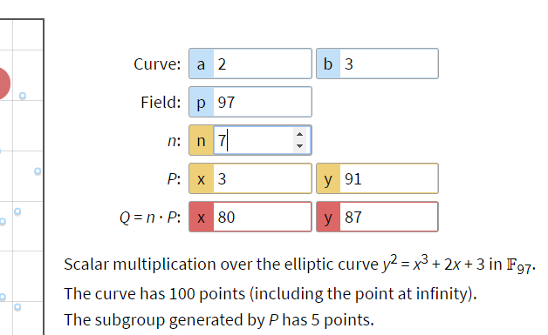

Bob also gets the result (80, 87), and uses 80 as the shared key.

## Notes

First, this example only has 5 possible results. You can see that by starting n: at 1 and just incrementing it. When you get to n =5, you will get the point at infinity (zero). After that, it will repeat. This is a poor choice of curve and base point.

For the large numbers used in the real world, the process of calculating the number of points in the subgroup is not simple. This is another reason why we use curves developed by cryptographers. <https://en.wikipedia.org/wiki/Counting_points_on_elliptic_curves>

Since Alice’s private key is 9 and Bob’s is 7, the result is that they both effectively multiply the base point by 9 * 7 = 63. Since our subgroup size is 5, 63 mod 5 = 3 gives the same result.